

TRIBHUVAN UNIVERSITY
FACULTY OF HUMANITIES AND SOCIAL SCIENCES

Expense Tracker

A Project Report

Submitted to
Department of Computer Application
Madan Bhandari Memorial College

In partial fulfillment of the requirements for the Bachelors in Computer Application

Submitted By:
Niraj Thapa (6-2-432-132-2023)
Raj Chaudhary Tharu (6-2-432-137-2023)
April , 2026

Under the supervision of
Mr. Debesh Adhikari

Tribhuvan University
Faculty of Humanities and Social Sciences
Madan Bhandari Memorial College

Supervisor’s Recommendation

I hereby recommend that this project prepared under my supervision by Niraj Thapa and Raj Chaudhary Tharu entitled “Expense Tracker” in partial fulfillment of the requirements for the degree of Bachelor of Computer Application is recommended for the final evaluation.

Signature:
Mr. Debesh Adhikari
Project Supervisor
Madan Bhandari Memorial College (MBMC)
New Baneshwor, Kathmandu


Tribhuvan University
Faculty of Humanities and Social Sciences
Madan Bhandari Memorial College

LETTER OF APPROVAL

This is to certify that this project prepared by Niraj Thapa and Raj Chaudhary Tharu entitled “Expense Tracker” in partial fulfillment of the requirements for the degree of Bachelor in Computer Application has been evaluated. In our opinion it is satisfactory in terms of scope and quality as a project for the required degree.

……………………….  Mr. Debesh Adhikari  Project Supervisor  Madan Bhandari Memorial College  New Baneshwor, Kathmandu | …………………….  Mr.Naw Raj Joshi  Coordinator  Madan Bhandari Memorial College  New Baneshwor, Kathmandu
……………………  Internal Examiner | …………………………  External Examiner

ABSTRACT

The Expense Tracker is a web-based application designed to automate and streamline personal financial management, enhancing efficiency in recording, categorizing, and analyzing daily expenditures. Developed using React (frontend), PHP (backend), and MySQL (database), the system provides a robust and user-friendly platform for individuals to manage their expenses, track spending patterns, and achieve budget goals.
The system implements a role-based access control model comprising three distinct user roles: Admin, Parent, and Student. The Admin role provides system-wide oversight including user management and configuration control. The Parent role enables family-level financial monitoring, allowing parents to link their accounts with student accounts and gain read-only access to their children's financial dashboards and spending behavior. The Student role is designed for personal financial tracking, enabling students to record and manage their day-to-day expenses independently. This hierarchical role structure ensures appropriate data access and privacy at every level.
Key features of the system include user authentication, expense CRUD operations, predefined and custom expense categories, date-based and category-based filtering, and visual spending reports using charts and summaries. The Expense Tracker supports multi-user accounts with separate data isolation, ensuring complete privacy for each user. To enhance security, the system implements JWT authentication with bcrypt password hashing and protection against SQL injection and XSS attacks. A search facility allows users to efficiently locate expenses based on date, category, or amount. By digitizing personal expense tracking, the system minimizes manual effort, reduces financial errors, and enhances the overall user experience.

Key words: Expense Tracking, Budget Management, Personal Finance, React, PHP, MySQL Database, Role-Based Access Control, Family Linking

Acknowledgement

On this great occasion of the successful completion of our project, we would like to express our sincere gratitude to our Supervisor Mr. Debesh Adhikari for his valuable guidance and continuous support throughout the development of this project
We would also like to extend our heartfelt thanks to our Program Coordinator Naw Raj Joshi for providing us with this wonderful opportunity to work on the “Expense Tracker”. Their support, encouragement, and insightful suggestions have been instrumental in the successful completion of this project
Without their valuable guidance, this project would not have been possible. Their expertise and recommendations have helped us in various phases, from planning and design to implementation and testing. We truly appreciate their contribution and assistance.
Lastly, we assure that this project has been developed with our own efforts, and it is an original work.

Niraj Thapa
Raj Chaudhary Tharu

Table of Contents
ABSTRACT iii
Acknowledgement iv
LIST OF ABBREVIATION vii
LIST OF FIGURES viii
LIST OF TABLES ix
Chapter 1 Introduction 1
1.1 Introduction 1
1.2 Problem Statement 1
1.3 Objectives 2
1.4 Scopes and Limitation 2
1.5 Report Organization 2
Chapter 2 Background Study and Literature Review 5
2.1 Background Study 5
2.2 Literature Review 5
Chapter 3 System Analysis and Design 8
3.1 System Analysis 8
3.1.1 Requirement Analysis 8
3.1.2 Feasibility Analysis 11
3.1.3 Data Modelling (ER-Diagram) 13
3.1.3 Process Modelling (DFD) 13
3.2 System Design 15
3.2.1 Architectural Design 15
3.2.2 Database Schema Design 16
3.2.3 Interface Design 16
3.2.4 Physical Data Flow Diagram 17
Chapter 4 Implementation and Testing 18
4.1 Implementation 18
4.1.1 Tools Used 18
4.1.2 Implementation Details of Module 18
4.2 Testing 20
4.2.1 Test cases for Unit Testing 20
4.2.2 Test Case for System Testing 23
Chapter 5 Conclusion and Future Recommendations 25
5.1 Outcomes 25
5.2 Conclusion 25
5.3 Future Recommendations 25
References 27
APPENDIX 28

LIST OF ABBREVIATION

API Application Programming Interface
CSS Cascading Style Sheets
CRUD Create, Read, Update, Delete
DFD Data Flow Diagram
ER Entity Relationship
HTML Hypertext Markup Language
HTTPS Hypertext Transfer Protocol Secure
JSON JavaScript Object Notation
OWASP Open Web Application Security Project
PHP Hypertext Preprocessor
SQL Structured Query Language
UI User Interface
URL Uniform Resource Locator
XAMPP Cross-Platform, Apache, MySQL, PHP, and Perl
XSS Cross-Site Scripting

LIST OF FIGURES
Figure 3.1 Agile Methodology 8
Figure 3.2 Use-Case Diagram 10
Figure 3.3 Gannt Chart 12
Figure 3.4 ER-Diagram 13
Figure 3.5 Level 0 DFD of Expense Tracker 14
Figure 3.6 DFD Level 1 14
Figure 3.7 Architectural Design of Expense Tracker System 15
Figure 3.8 Database Schema Design of Expense Tracker System 16
Figure 3.9 Login 17
Figure 3.10 Dashboard 17
Figure 3.11 Physical DFD diagram 17

LIST OF TABLES

Table 4.1 Tool Used 18
Table 4.2 Login Test Case 20
Table 4.3 Registration Test Case 20
Table 4.4 Add Expense Test Case 21
Table 4.5 Add Income Test Case 21
Table 4.6 Budget Management Test Case 22
Table 4.7 Category Management Test Case 22
Table 4.8 Family Linking & Roles Test Case 22
Table 4.9 System Testing 23

: Introduction

Introduction
The Expense Tracker is a web-based application developed to address these challenges by providing a centralized, intuitive, and intelligent platform for personal financial management. It replaces the inefficiencies of traditional paper-based records and manual spreadsheets with a dynamic system that automates expense recording, provides real-time spending summaries, and delivers visual analytics to help users make informed financial decisions. The application is built using React for the frontend, PHP for server-side processing, and MySQL for persistent data storage, forming a reliable and scalable three-tier architecture.
A defining feature of the Expense Tracker is its role-based access control system. The application supports three user roles: Admin, Parent, and Student. The Admin has complete control over the system, managing users and overseeing all platform activities. The Parent role introduces a family financial monitoring dimension, enabling parents to link with their children's accounts and observe their spending habits in a read-only capacity without interfering with personal data. The Student role is tailored for everyday personal use, allowing students to log income and expenses, set budgets, and track their financial health over time.
Beyond basic expense tracking, the system supports advanced features such as recurring expense templates, future expense scheduling, receipt image uploads, budget health alerts, audit logging, and category-wise visual reports using chart libraries. These features combine to create a comprehensive financial management ecosystem that is practical, secure, and scalable for a growing user base.
By digitizing and automating the entire expense management lifecycle, the Expense Tracker empowers users to cultivate better financial habits, reduce wasteful spending, and work toward achieving their financial goals. It demonstrates how modern web technologies can be leveraged to solve everyday personal financial challenges and deliver meaningful improvements in financial awareness and literacy.

Problem Statement
- Inefficient and time-consuming manual tracking of daily expense records.
- Frequent errors in calculating monthly spending due to lost bills and human error.
- Limited visibility into expense patterns and budget adherence over time.
- Lack of transparency for parents trying to monitor their children's financial habits.
- Absence of real-time reporting and visual summaries for financial decision-making.

Objectives
- To design and implement a user-friendly system for managing personal daily expenses.
- To enable real-time recording, categorizing, and filtering of expenses.
- To implement role-based access control like admin, parent and student

Scopes and Limitation
Scope
- Efficient Expense Tracking and Management: Tracks real-time spending by category and date, and allows easy addition, editing, and deletion of expense entries in the system.
- Role-Based User Management: Supports distinct dashboards like admin for system oversight, parents for family oversight, and students personal tracking.
- Expense Filtering and History: Facilitates filtering of expense records by date range, category, or amount and displays complete expense history with sorting options.
- Reporting and Visualization: Automatically generates spending summaries and visual charts showing category-wise expense distribution and monthly trends.

Limitations
- Limited to Personal Use: The system supports personal expense tracking only; no business accounting or multi-currency features are included.
- No Bank Integration: The system does not support automatic bank account or credit card synchronization; all entries must be added manually.
- Web-Based Only: No offline mode or dedicated mobile application is available; the system is accessible through web browsers only.

Report Organization
This report is organized into five chapters that collectively cover the entire development lifecycle of the Expense Tracker system, from problem identification to implementation and future recommendations.
Chapter 1 – Introduction: This chapter introduces the Expense Tracker project by presenting the background, problem statement, and objectives. It identifies the inefficiencies of manual expense tracking and explains the need for a digital, role-aware solution. The scope and limitations of the system are clearly outlined, specifying included features and existing constraints. The chapter concludes with the report organization, giving the reader a structured overview of what follows.
Chapter 2 – Background Study and Literature Review: This chapter traces the evolution of expense tracking systems from manual ledgers to modern web-based platforms and places the project within the Nepalese digital context. It reviews nine relevant research works, drawing direct connections between prior findings and design decisions made in this project. Topics covered include role-based access, secure authentication, real-time feedback, Agile development, and technology stack selection. The review establishes the academic foundation and justification for the system's core features.
Chapter 3 – System Analysis and Design: This chapter presents the complete analytical and design framework of the system. It documents functional and non-functional requirements, followed by technical, operational, economic, and schedule feasibility analyses. Data modelling is illustrated through an ER diagram, and system processes are described via DFD Level 0 and Level 1. The chapter also covers the three-tier architectural design, database schema, and user interface mockups for key screens.
Chapter 4 – Implementation and Testing: This chapter documents the tools and technologies used to build the system, including React, PHP, MySQL, Git, and VS Code. It then presents structured test cases for unit testing of individual modules such as login, registration, expense management, budget control, and family linking. System testing evaluates integrated scenarios including authentication flow, analytics generation, budget alerts, audit logging, and secure session management. Each test case records inputs, expected outcomes, actual results, and pass/fail status.
Chapter 5 – Conclusion and Future Recommendations: This chapter reflects on the project outcomes and evaluates the degree to which the defined objectives were successfully achieved. It summarizes key lessons learned throughout the development process, including the value of Agile iteration, structured testing, and teamwork. The chapter confirms that the Expense Tracker delivers a functional, secure, and user-friendly financial management platform. It concludes with future recommendations including mobile app development, bank integration, AI-based forecasting, and offline access capabilities.

: Background Study and Literature Review

Background Study
Effective management of personal finances is essential for ensuring financial stability and long-term user satisfaction. Individuals play a vital role in managing their own resources; however, traditional manual methods of tracking expenses, such as handwritten notebooks and paper ledgers have consistently proven to be inefficient and prone to human error. These manual processes hinder scalability, resource optimization, and overall financial efficiency.
In earlier times, individuals relied entirely on physical records to maintain logs of expenses and income. While functional on a small scale, such systems were labor-intensive, time-consuming, and susceptible to inaccuracies arising from missing receipts, arithmetic errors, and inconsistent recording habits. As personal spending grew more complex with the advent of online shopping, digital subscriptions, and cashless transactions, these manual systems became clearly inadequate.
The emergence of computer-based accounting software in the late 20th century marked a turning point in financial management. Applications such as Microsoft Money and Intuit's Quicken introduced users to digital ledgers, enabling automated calculations, categorization, and rudimentary reporting. With the growth of the internet and mobile technologies in the 21st century, cloud-based financial tools began to emerge, offering real-time synchronization, cross-device accessibility, and collaborative features that personal finance management had never seen before.
In the context of Nepal, digital financial literacy is growing steadily, though the adoption of personal expense tracking tools remains relatively low compared to more digitally advanced nations. Most individuals in Nepal still rely on informal methods of financial management. This gap presents a significant opportunity for locally tailored web-based solutions that are accessible, affordable, and designed with the needs of students, families, and young professionals in mind.

Literature Review
The rapid advancement of digital technologies has significantly transformed personal financial management, leading to the development of various expense tracking systems that help users make informed decisions and improve overall financial awareness. The literature in this domain spans across software engineering, human-computer interaction, personal finance, and behavioral economics.
Sharma, Bansal, and Kumari (2017) introduced a web-based personal expense management system using PHP and MySQL that demonstrated the feasibility of centralizing financial data through an online platform. Their study emphasized the importance of categorization and search functionality, concluding that structured data organization significantly improves users' ability to understand their spending patterns. The system they proposed served as an early model for the category-based tracking architecture adopted in this project [1].
Gurung (2022) examined the role of digital finance tools in improving personal financial management in the Nepalese context. The study found that individuals who actively used digital tracking tools demonstrated greater awareness of their spending habits and were more likely to adhere to personal budgets. The research highlighted that localized, simple interfaces were essential for adoption in markets with varying levels of digital literacy. This insight directly influenced the design philosophy of the Expense Tracker, particularly the decision to prioritize usability and role-specific dashboards [2].
Raghunathan and Soman (2020) explored the behavioral impact of real-time expense feedback on consumer spending. Their findings showed that users who received immediate visual summaries of their expenditures were more likely to modify their behavior to align with their financial goals. This research supports the inclusion of real-time chart visualizations such as pie charts for category distribution and line graphs for monthly trends as central features of the Expense Tracker [3].
Chen, Xu, and Wang (2019) investigated multi-role financial management systems within household contexts. Their study argued that transparent, supervised financial visibility between parents and children creates better financial accountability without compromising individual privacy. They proposed a model in which parents are granted read-only access to dependents' financial records, forming the conceptual basis for the Family Linking feature implemented in this project [4].
Kumar and Prasad (2021) conducted a comparative analysis of personal finance applications including Mint, YNAB (You Need A Budget), and Pocket Guard, evaluating them across dimensions of usability, security, and feature depth. Their analysis found that while commercial tools offered bank integration and AI-driven recommendations, they lacked role-based access and were not suited for educational or family settings. The gap identified in their study reinforced the rationale for building a custom expense tracker tailored for student and family use [5].
Yadav and Sharma (2020) discussed the importance of secure authentication mechanisms in web-based financial applications. They specifically recommended the use of JSON Web Tokens (JWT) for stateless session management and bcrypt hashing for password storage, noting that these two mechanisms together provide a strong foundation against common web security threats. Their recommendations are directly implemented in the security architecture of this Expense Tracker system [6].
Kim and Park (2018) reviewed the use of Agile methodology in the development of financial software systems. Their work demonstrated that iterative, feedback-driven development cycles resulted in significantly higher user satisfaction rates compared to waterfall-based approaches. They noted that Agile's adaptability was particularly valuable in financial applications where user needs evolve with changing spending habits and regulatory environments. The adoption of Agile methodology in the development of this Expense Tracker system is grounded in this evidence [7].
Patel, Joshi, and Mehta (2022) explored budget alert systems and their effectiveness in preventing overspending. Their research demonstrated that color-coded visual indicators and threshold-based alerts were among the most effective mechanisms for drawing user attention to budget breaches. Their findings informed the design of the budget health tracking module in the Expense Tracker, which displays critical red-state alerts when users exceed their defined spending limits [8].
Finally, Thapa and Khatiwada (2023) discussed the use of React and PHP in developing lightweight, scalable web applications for developing countries, emphasizing that this technology stack is particularly well-suited for environments where server costs must remain low while application responsiveness must remain high. Their technical evaluation supports the technology choices made in this project [9].
Taken together, the existing literature underscores the value of role-based, visually rich, and security-focused expense tracking systems. While numerous commercial solutions exist, there remains a clear need for locally adaptable, educationally oriented platforms that cater specifically to student populations and family oversight structures. The Expense Tracker developed in this project addresses precisely these gaps by combining best practices from the literature with the practical requirements of the Nepali academic and family content

: System Analysis and Design

System Analysis
Agile methodology is going to be used while building the website. It facilitates risk management, continuous improvement, and user-centric design. This project has specific documentation, various changes, frequent outputs, and well-understood technology. So, to build this system, agile methodology can be used.

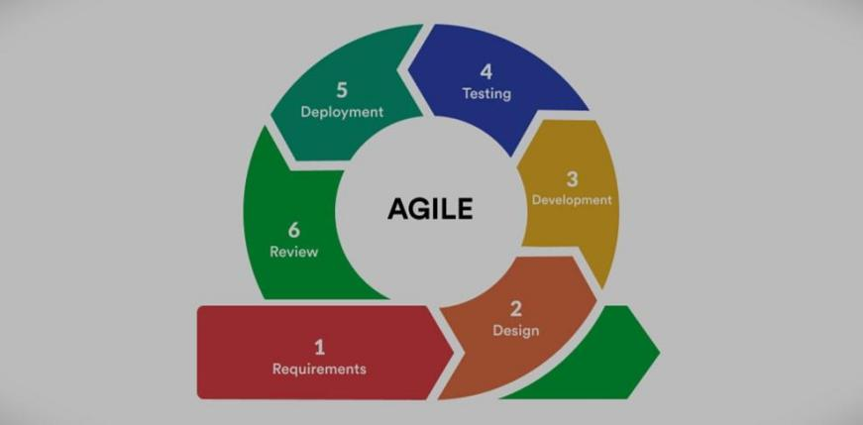
Figure 3.1 Agile Methodology

Requirement Analysis
Requirement analysis is done while developing a system and before implementing it. It is necessary to analyze the whole system requirement. There are functional and non-functional requirements to be considered while determining the requirements of the system which outline what the system should do and the quality standards it must adhere to:
i. Functional Requirements
Functional requirements define the specific operations and behaviors the system must support to meet user needs. The following are the core functional requirements of the Expense Tracker.
- User Authentication: The system must allow users to register with their name, email, password, and role. Secure login is enforced through JWT-based session management, and users must be able to update their profile and change their password at any time.
- Role-Based Access Control: The system must support three roles i.e Admin, Parent, and Student, with a dedicated dashboard and defined access permissions. Admins manage the entire system, Parents monitor linked students in read-only mode, and Students manage their own financial data independently.
- Expense Management: Users must be able to add, edit, and delete expense entries with fields for category, amount, date, and description. The system must also support future expense scheduling and recurring expense templates for automated tracking.
- Income Management: Users must be able to log income by specifying the source, amount, and date. A monthly income goal feature must allow users to compare planned income against actual earnings over time.
- Budget Management: The system must allow users to set overall monthly and category-wise spending limits. A real-time budget health indicator must alert users when spending approaches or exceeds the defined threshold.
- Category Management: The system must provide predefined expense categories that cannot be modified, while also allowing users to create and manage custom categories and sub-categories for personalized tracking.
- Family Linking: Parents must be able to send link requests to student accounts via email, with students having the ability to accept or reject them. Once linked, parents gain read-only access to the student's dashboard, and either party may unlink at any time.
- Filtering, Search and Reporting: Users must be able to filter expense records by date, category, or amount and search for specific transactions in real time. The system must generate visual reports including pie charts and line graphs that update automatically with any data change.
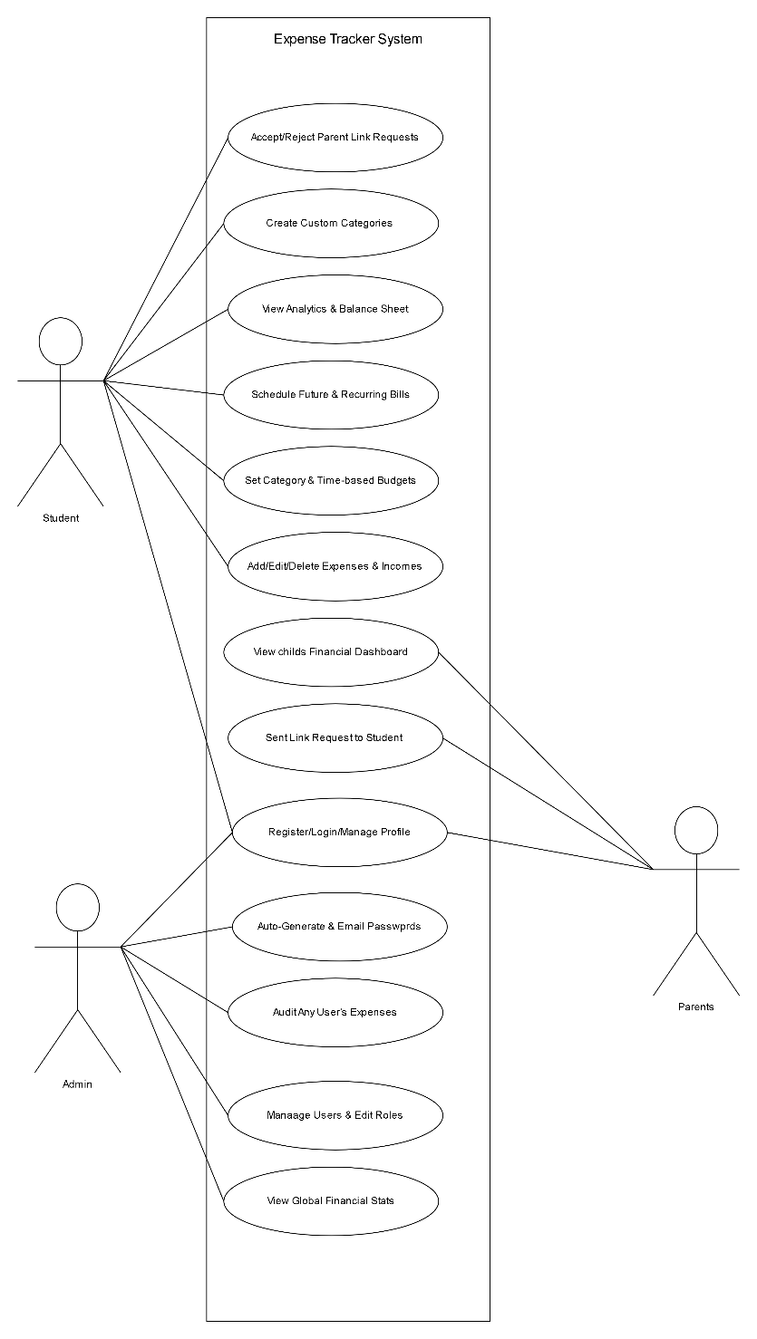

Figure 3.2 Use-Case Diagram
ii. Non-functional Requirements
These are the performance and quality attributes that the system must meet to ensure usability, reliability, and scalability.
- Performance: The system should respond quickly to user actions, with expense searches, updates, and report generation processed within seconds. It must handle a large number of users and expense records without performance degradation.
- Scalability: The system must be scalable to accommodate a growing number of users and expense records as usage expands.
- Usability: The user interface should be intuitive, simple, and require minimal training for users to navigate and use efficiently. Both new and experienced users should be able to use the system.
- Security: The system must enforce strong authentication protocols (e.g., username, password) to protect sensitive data. User data must be isolated per account, ensuring the right level of access to data and functionality.
- Maintainability: The system should be easy to maintain, enabling regular updates, bug fixes, and feature enhancements without disrupting operations. Documentation should be available for both users and developers for maintenance tasks.

iii. Technical Requirements
Technical requirements specify the hardware, software, and system environment needed for the system to function.
- Hardware Requirements: The system should run on standard server hardware or cloud infrastructure, with provisions for scalable storage and processing power.
- Software Requirements: The system should be developed using PHP as the backend scripting language and React as the frontend framework. It must use a reliable database system such as MySQL to store and manage data.
- Platform Compatibility: The system should be accessible via modern web browsers (e.g., Chrome, Firefox, Safari, Edge).

Feasibility Analysis
The following are the feasibility study of Expense Tracker System:
i. Technical Feasibility
The system is technically feasible as it uses widely supported technologies such as React, PHP, and MySQL. These tools provide a reliable and scalable platform for web development. Security is ensured through bcrypt encryption and responsive design principles.
ii. Operational Feasibility
The system is operationally feasible as it integrates smoothly into users’ daily financial activities. It simplifies expense recording, categorization, and reporting, reducing manual effort and errors. The user-friendly interface requires minimal training.
iii. Economic Feasibility
The system is economically feasible because it uses open-source technologies such as React, PHP, MySQL, and XAMPP, minimizing development costs. It reduces paper-based tracking and manual calculations, improving cost efficiency.
iv. Schedule Feasibility
The project is schedule feasible as it was completed within the allocated academic timeframe. The development process was divided into phases including planning, analysis, design, implementation, testing, and documentation. A Gantt chart was prepared to manage tasks and monitor progress. By following the planned timeline and adopting an Agile approach, the project milestones were achieved successfully without significant delays.

Figure 3.3 Gannt Chart

Data Modelling (ER-Diagram)

Figure 3.4 ER-Diagram

Process Modelling (DFD)

Level 0:Context DFD
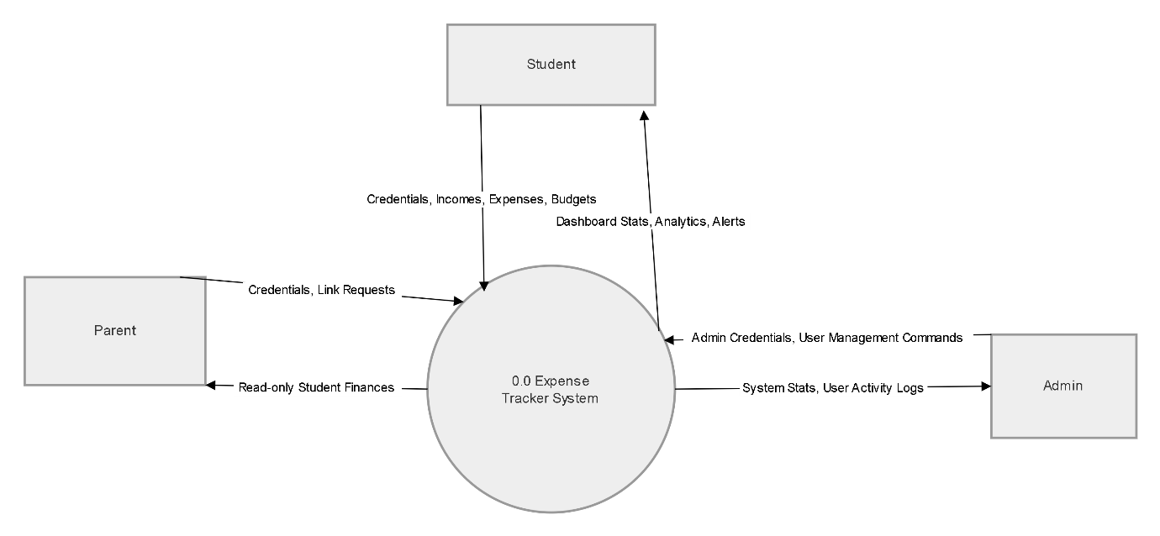

Figure 3.5 Level 0 DFD of Expense Tracker
Level 1 DFD

Figure 3.6 DFD Level 1

System Design

Architectural Design

Figure 3.7 Architectural Design of Expense Tracker System

Database Schema Design

Figure 3.8 Database Schema Design of Expense Tracker System

Interface Design
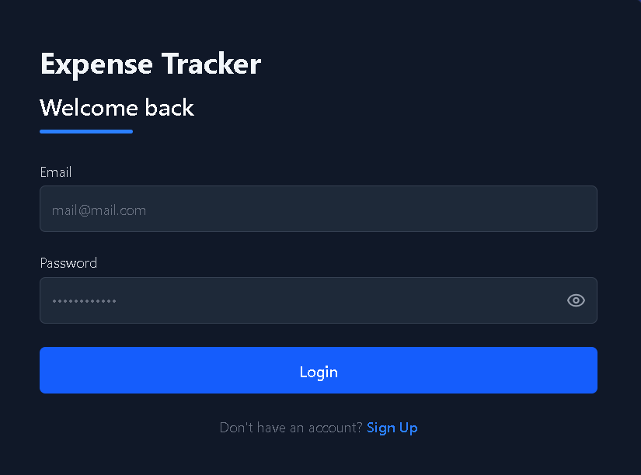
Figure 3.9 Login
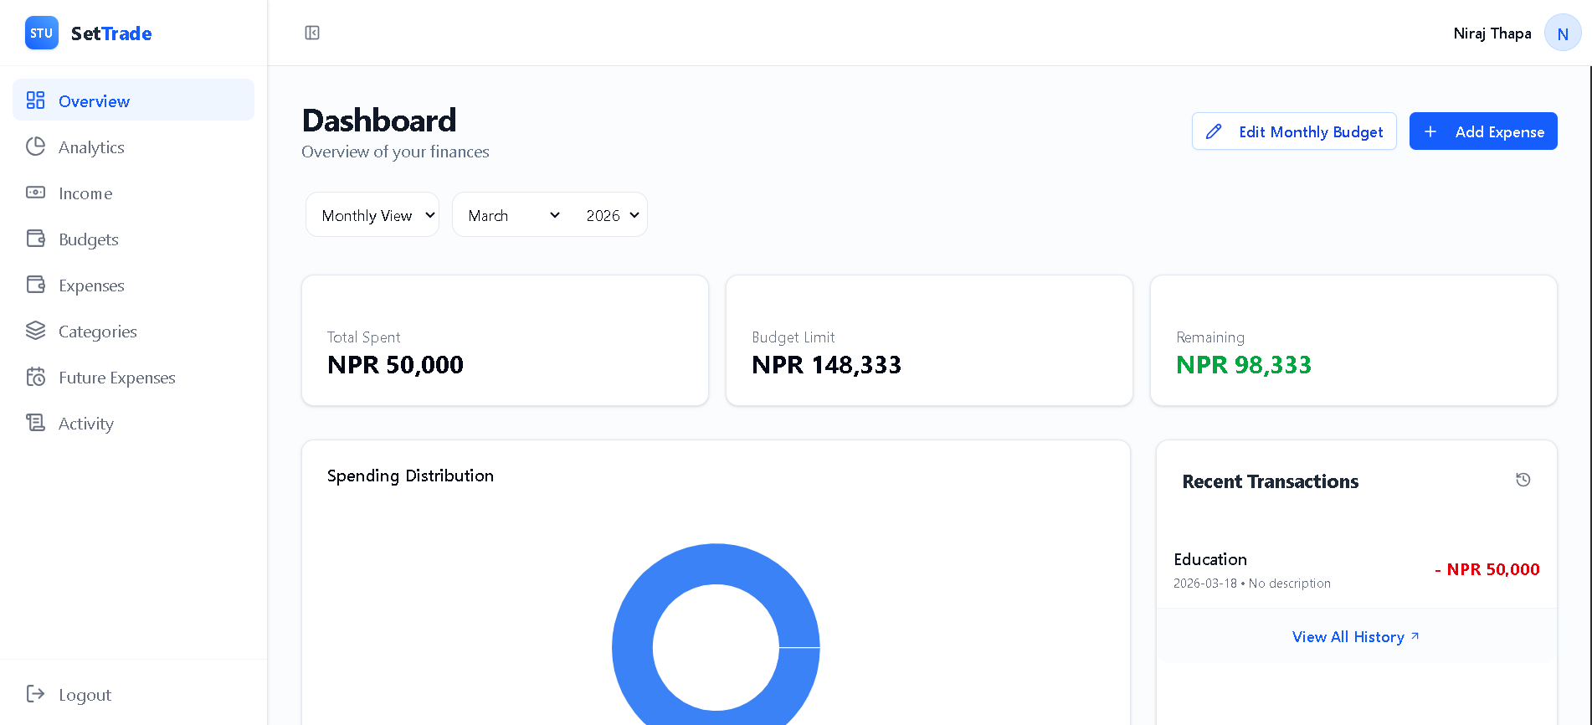
Figure 3.10 Dashboard

Physical Data Flow Diagram
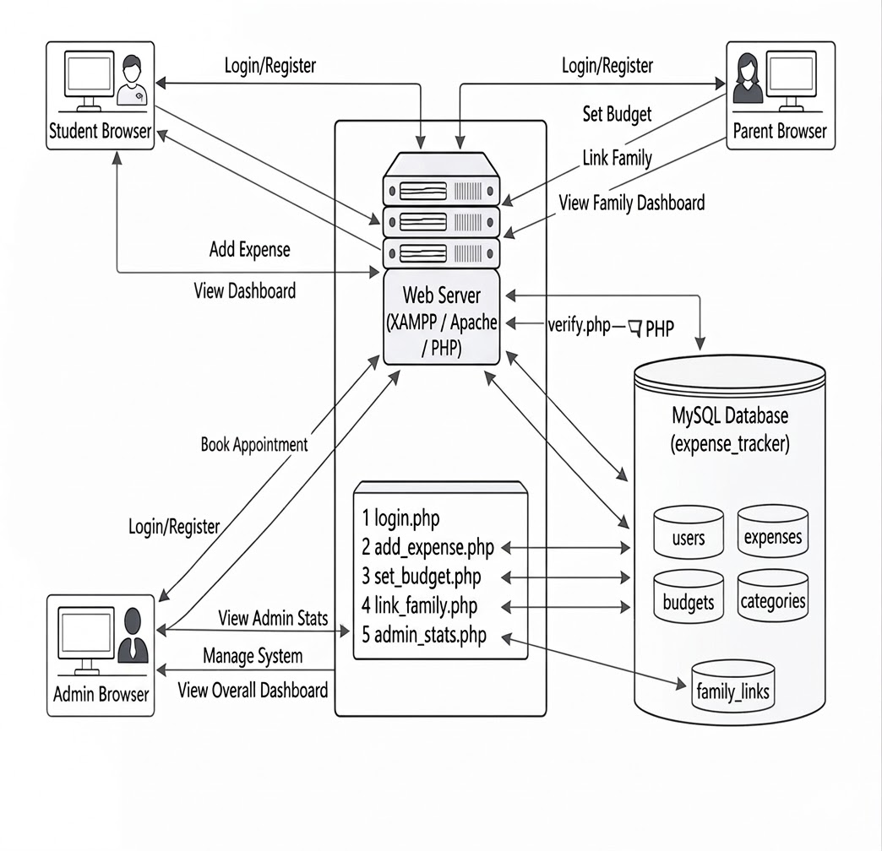
Figure 3.11 Physical DFD diagram

:Implementation and Testing

Implementation
During the implementation phase of Project Expense Tracker, a combination of programming language, frameworks and development tools were utilized to create a comprehensive and user-friendly system.

Tools Used
Table 4.1 Tool Used
Category | Technologies / Tools
Frontend Technologies | HTML, CSS, JavaScript, React
Backend Technologies | PHP
Database Technologies | MySQL
Version Control | Git
Development  Environment | VS Code
System Design & Diagramming | Draw.io, DrawSQL

Implementation Details of Module
The proposed system is composed of several distinct modules designed to handle personal finance tracking, family monitoring, and system administration. These include the Authentication Module, Student (User) Module, Parent (Family) Module, Admin Module, Transaction (Expense/Income) Module, Budgeting Module, and Analytics Module. Below is an overview of each module:
- Authentication & Profile Module:
In this module, users can register for the system by selecting a role (Student or Parent) and providing details such as their name, email, password, and optional banking details. The system securely hashes passwords and sends a welcome email upon successful registration. During login, the system verifies credentials and issues a secure JWT (JSON Web Token) for session management. Users can also update their profile details, change their password, and view a detailed system activity log.
- Student (User) Module:
This is the core module for standard users. Upon logging in, students access a personalized dashboard where they can oversee their financial status. They can manage custom categories and sub-categories, view recent transactions, and approve or decline "Family Link" requests sent by parents.
- Parent (Family) Module:
The parent module is designed for family financial monitoring. Parents can send a link request to a student's email address. Once the student approves the request, the parent gains access to a read-only dashboard. Here, parents can drill down into their child's financial health, view transaction histories, monitor budget limit adherence, and see category-wise spending breakdowns without having the ability to alter the data.
- Admin Module:
The admin module is strictly restricted to system administrators. Upon logging in, the admin accesses a high-level system dashboard displaying aggregate statistics, such as total platform income, expenses, and budget limits visualized through pie charts. The admin possesses full user management capabilities, including the ability to view individual user expense records, edit user information, delete users entirely, and auto-generate new secure passwords to email to users who are locked out.
- Transaction (Income & Expense) Module:
This module handles the core data entry of the application.
  - Income: Users can log financial inflows, specifying the source, date, and amount.
  - Expenses: Users can log expenditures, categorize them, and upload image files (receipts/bills) for record-keeping.
  - Advanced Expenses: Users can schedule Future Expenses to be processed at a later date, and set up Recurring Expenses (weekly, monthly, or yearly) which the system automatically generates and processes based on the specified frequency.
- Budgeting Module:
This module allows users to proactively manage their spending limits. Users can set overall Weekly, Monthly, or Yearly budgets, as well as specific limits for individual expense categories (e.g., Food, Transport). The system tracks real-time spending against these limits and provides visual progress bars and warnings when users approach or exceed their set budgets.
- Analytics & Reporting Module:
This module provides deep visual insights into the user's financial habits. It utilizes charts to show spending distribution and daily monthly trends. Furthermore, it generates an automated Financial Health Report that compares spent amounts against limits (providing conditional warnings or positive reinforcement) and a fully itemized Balance Sheet that calculates net surplus or deficit over a given period.

Testing
Testing is the process of determining whether the system works effectively and efficiently. Testing does not only include debugging. It also checks for quality assurance, validation and verification, reliability and availability estimation. Testing can be done in different levels.

Test cases for Unit Testing
The unit testing part of testing methodology is the testing of individual software modules or components that make up a web application or system.
Table 4.2 Login Test Case
SN | Action | Input | Expected Outcome | Actual Outcomes | Test Result
1 | Empty Submission | NULL | Email and password required | Email and password required | PASS
2 | Enter Email only | No Password | Incomplete submission form | Password field triggers HTML required flag | PASS
3 | Enter Password only | No Email | Incomplete submission form | Email field triggers HTML required flag | PASS
4 | Invalid Credentials | wrong@mail.com / pass | Invalid email or password | Invalid email or password | PASS
5 | Valid Login | Valid Email & Password | Redirect to Dashboard | User logged in, token saved, redirected | PASS

Table 4.3 Registration Test Case
SN | Action | Input | Expected Outcomes | Actual Outcomes | Test Status
1 | Empty Submission | NULL | Error displayed | HTML required validation triggers | PASS
2 | Validate Name | Numbers in name (e.g., "John123") | Names should contain only letters | Names should contain only letters | PASS
3 | Invalid Email Format | "testuser" | Invalid email address format | Invalid email address format | PASS
4 | Short Password | "123" | Password must be at least 6 chars | Password must be at least 6 characters | PASS
5 | Duplicate Email | Existing Email | Registration fail | Email already registered | PASS
6 | Valid Registration | All valid info + Role (Student) | Successful registration & Welcome Email sent | User registered, email received, redirected to Login | PASS

Table 4.4 Add Expense Test Case
SN | Action | Input | Expected Outcomes | Actual Outcomes | Test Status
1 | Empty Submission | Null | Category, Amount, and Date required | Category, Amount, and Date required | PASS
2 | Future Date Selection | Date: 2026-12-31 | Schedule the expense for future | Expense scheduled for future date | PASS
3 | Submit with Recurring | Frequency: "Monthly" | Creates Recurring Template | Recurring expense set up successfully | PASS
4 | Submit with Photo | Amount + Receipt Img (.png/.jpg) | Entry saved with file uploaded | Expense added with attachment successfully | PASS
5 | Valid Normal Submit | Correct Data (Past/Today) | Submitted Successfully | Record added to main expense list | PASS

Table 4.5 Add Income Test Case
SN | Action | Input | Expected Outcomes | Actual Outcomes | Test Status
1 | Submit without Source | No Source | Incomplete Submission | Source and Amount are required | PASS
2 | Negative/Zero Amount | 0 or -5000 | Error Message | Source and Amount are required | PASS
3 | Add Monthly Goal | Month, Year, Amount | Updates monthly income plan | Income plan updated | PASS
4 | Valid Income Submit | Source, Amount, Date | Successful transaction | Income record added, logged in activity | PASS

Table 4.6 Budget Management Test Case
SN | Action | Input | Expected Outcomes | Actual Outcomes | Test Status
1 | Invalid Budget Logic | Weekly limit > Monthly limit | System Block | Weekly budget cannot exceed Monthly | PASS
2 | Set Category Limit | Food: 5000 | Limit saved into category budgets | Category limit applied successfully | PASS
3 | Set Monthly Planner | Week 1-4 amounts | Total auto-calculates and saves | Total monthly budget updated & logged | PASS
4 | Update Overall Budget | New Amount: 20000 | Budget updated | Limit changed successfully | PASS

Table 4.7 Category Management Test Case
SN | Action | Input | Expected Outcomes | Actual Outcomes | Test Status
1 | Add Empty Category | Null | Category name is required | Category name is required | PASS
2 | Add Duplicate Category | "Food" (System category) | Prevent duplicate creation | Category 'Food' already exists! | PASS
3 | Edit System Category | Click Edit on "Food" | System blocks action | System categories cannot be edited | PASS
4 | Delete System Category | Click Delete on "Food" | System blocks action | Failed (You cannot delete system categories) | PASS
5 | Add Sub-Category | Valid Name under "Food" | Sub-category saved | Sub-category added to main category | PASS

Table 4.8 Family Linking & Roles Test Case
SN | Action | Input | Expected Outcomes | Actual Outcomes | Test Status
1 | Parent Requests Link | Valid Student Email | Request added to family links | Link request sent to student | PASS
2 | Parent Requests Admin | Admin/Parent Email | Block invalid request | You can only link student accounts | PASS
3 | Student Accepts Link | Click "Accept" on banner | Status changes to 'ACTIVE' | Link activated, Parent gains read-only access | PASS
4 | Unlink Parent/Student | Click "Unlink" button | Connection deleted | Parent successfully unlinked | PASS

Test Case for System Testing
Table 4.9 System Testing
SN | Action | Input | Expected Outcomes | Actual Outcomes | Test Status
1 | User Authentication | Valid Email & password | JWT token generated, user redirected based on Role | Logged in successfully; redirected to correct Dashboard | PASS
2 | Financial Search | Start Date & End Date | Expense table filters to show only matching transactions | Matching expenses displayed correctly | PASS
3 | Receipt Image Viewer | Click "Eye" icon on expense | Modal opens showing the uploaded receipt image | Image rendered correctly via backend path | PASS
4 | Data Modification | Edit existing expense amount | Changes reflected across Dashboard, Charts, and Analytics | Changes saved and reflected in all reports immediately | PASS
5 | Future Planning Flow | Click "Process" on due date | Record moves from Future table to Actual Expense table | Future expense processed into actual list successfully | PASS
6 | Analytics Generation | Select Monthly/Yearly view | Recharts (Pie/Line) rendered with accurate NPR data | Charts rendered accurately with real-time data | PASS
7 | Budget Tracking Alert | Spend > Budget Limit | System changes UI to Red and shows "Over Budget" status | Health report accurately shows Critical/Over Budget | PASS
8 | Audit Log Generation | Add/Edit/Delete any record | System records the action in transaction logs with timestamp | Activity log entry created with correct badge colors | PASS
9 | Admin Auto-Reset | Admin clicks "Reset Password" | Generates random 10-char password, saves to DB, emails user | Random password generated and emailed successfully | PASS
10 | Profile Security | Change Password | Valid Current & New password | Password updated and Security Alert email sent | PASS
11 | Secure Logout | Click Logout button | LocalStorage cleared, state reset, redirected to Login | Session terminated and redirected to login page | PASS

:Conclusion and Future Recommendations

Outcomes
The development of the Expense Tracker System provided valuable learning experiences that contributed to its success. Clearly defining the project scope, adopting Agile methodology, and maintaining effective communication were essential in achieving the objectives. Continuous collaboration, structured testing, and early issue resolution ensured a smooth development process.
The final outcome is a functional and scalable system featuring user authentication, expense management, category customization, search and filtering, and visual financial reports. Overall, the project enhances personal financial awareness and simplifies expense tracking, contributing positively to better financial management.

Conclusion
The completion of the “Expense Tracker” project marks an important achievement in personal finance management. The system successfully provides a user-friendly platform for adding, editing, deleting, and managing expenses efficiently. By following Agile methodology, the team ensured continuous improvement and delivered a reliable and adaptable solution.
This project strengthened our technical skills in web development and project management while also enhancing teamwork, communication, and problem-solving abilities. Overall, the Expense Tracker promotes better financial discipline and budget management, demonstrating how technology can positively improve personal financial management.

Future Recommendations
Although the Expense Tracker has successfully achieved its objectives, several enhancements can further improve its functionality and user experience:
- Budget Planning & Alerts: Allow users to set category-wise spending limits and receive notifications when nearing or exceeding budgets.
- Mobile Application: Develop dedicated iOS and Android apps for convenient, on-the-go expense tracking.
- Bank Integration: Enable automatic synchronization with bank accounts or credit cards to reduce manual entry and improve accuracy.
- AI-Based Forecasting: Use predictive analytics to analyze spending patterns and forecast future expenses.
- Offline Mode: Provide offline access to record and view expenses without an internet connection.

References

[1] R. Sharma, R. Bansal, and P. Kumari, "Personal Expense Management: A Web-based Approach," International Journal of Computer Applications, vol. 162, no. 4, pp. 45–49, 2017.
[2] M. S. Gurung, "The Role of Digital Finance Tools in Enhancing Personal Financial Management in Nepal," Journal of Educational Technology and Library Science, vol. 9, no. 2, pp. 58–64, 2022.
[3] R. Raghunathan and D. Soman, "Real-Time Expense Feedback and Consumer Spending Behavior: An Empirical Study," Journal of Consumer Psychology, vol. 30, no. 3, pp. 412–429, 2020.
[4] Y. Chen, H. Xu, and L. Wang, "Multi-Role Household Financial Management Systems: Transparency, Privacy, and Accountability," IEEE Transactions on Consumer Electronics, vol. 65, no. 2, pp. 198–207, 2019.
[5] A. Kumar and R. Prasad, "Comparative Analysis of Personal Finance Applications: Usability, Security, and Role-Based Access," International Journal of Information Systems and Management, vol. 14, no. 1, pp. 33–52, 2021.
[6] S. Yadav and P. Sharma, "Secure Authentication in Web-Based Financial Applications: JWT and Bcrypt Best Practices," International Journal of Network Security, vol. 22, no. 5, pp. 741–750, 2020.
[7] J. Kim and H. Park, "Agile Methodology in Financial Software Development: A Review of User Satisfaction Outcomes," Journal of Software Engineering Research and Development, vol. 6, no. 1, pp. 1–18, 2018.
[8] N. Patel, R. Joshi, and S. Mehta, "Budget Alert Systems and Overspending Prevention: A Behavioral Study," Journal of Financial Planning, vol. 35, no. 3, pp. 87–101, 2022.
[9] B. Thapa and S. Khatiwada, "React and PHP for Scalable Web Applications in Developing Economies," Asian Journal of Computer Science and Technology, vol. 12, no. 1, pp. 22–31, 2023.

APPENDIX



